# Title: Portfolio Website using HTML and CSS

Description:

A portfolio website is a website that represents you online on the web pages. It contains different sections like Introduction to Yourself, About You, Your Services, Your Contact Details, and Your Portfolio. We are going to build all of the sections with an interactive and attractive web design that attracts more visitors using HTML and CSS.

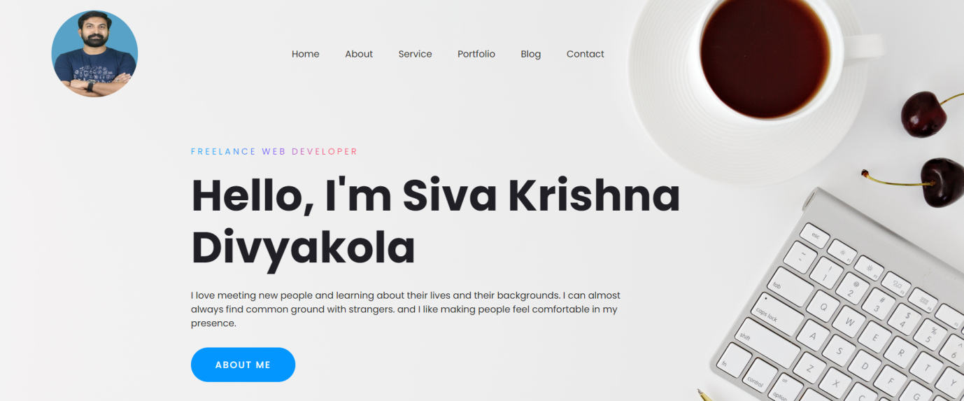

**Source Code Link:**

https://github.com/divyakola/Portfolio-website-with-HTML-CSS